App Picture | App Name | Cost & Description of App | App Link
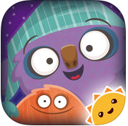 | Goodnight Mo ~ 3D Interactive Pop-Up Book  By StoryToys Entertainment Limited | $2.99 – Interactive story book | https://itunes.apple.com/us/app/goodnight-mo-3d-interactive-pop-up-book/id706000131?mt=8
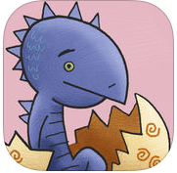 | Dino-Store  By Bluemarker | Free – story book for children | https://itunes.apple.com/us/app/dino-store/id585701049?mt=8
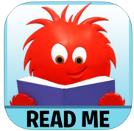 | Read Me Stories - Children's books  By 8Interactive Limited | Free – one free story a day for kids | https://itunes.apple.com/us/app/read-me-stories-childrens-books/id362042422?mt=8
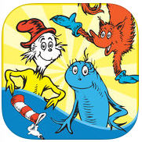 | Dr. Seuss Treasury  By Oceanhouse Media | Free – all of the Dr. Seuss books available for purchase | https://itunes.apple.com/us/app/dr-seuss-treasury/id909110675?mt=8
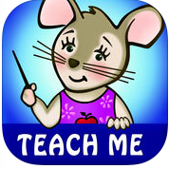 | TeachMe: Kindergarten  By 24x7digital LLC | $1.99 – games for all of the subjects taught in kindergarten | https://itunes.apple.com/us/app/teachme-kindergarten/id336689375?mt=8
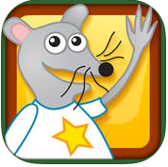 | Starfall Learn to Read  By Starfall Education | Free – app to teach children how to read | https://itunes.apple.com/us/app/starfall-learn-to-read/id551817261?mt=8
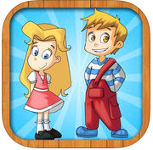 | Sentence Builder App  By AbiTalk Incorporated | $5. 99 – app designed to learn about words, sentences, pronunciation, grammar, and punctuation. | https://itunes.apple.com/us/app/sentence-builder-app/id512507120?mt=8
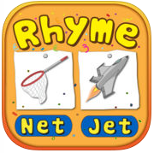 | Bud's Rhyming Words - Kids learn word families, CVC, short & long vowel words  By Nimble Minds LLC | $3.99 – learn all about rhyming | https://itunes.apple.com/us/app/buds-rhyming-words-kids-learn-word-families-cvc-short/id866965757?mt=8
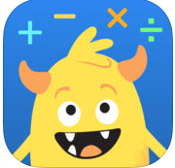 | GO Math! GO – Fun learning for grades K, 1st & 2nd  By Houghton Mifflin Harcourt | Free – Math app based off the math curriculum used at school | https://itunes.apple.com/us/app/go-math-go-fun-learning-for-grades-k-1st-2nd/id1099254173?mt=8
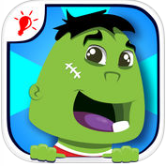 | Wonster Words - ABC Phonics Spelling Games for Kid  By 77Sparx Studio, Inc. | Free – app to learn about word families and rhyming | https://itunes.apple.com/us/app/wonster-words-abc-phonics-spelling-games-for-kid/id881119321?mt=8
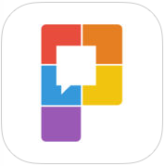 | Pocket Sight Words  By Cortes Global Pty Ltd.  View More by This Developer | $1.99 – app to learn sight words | https://itunes.apple.com/us/app/pocket-sight-words/id1044466535?mt=8
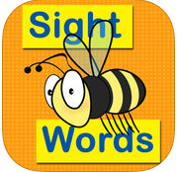 | Sight Words Sentence Builder  By Sierra Vista Software | $1.99 – app that uses sight words to make sentences. | https://itunes.apple.com/us/app/sight-words-sentence-builder/id527718967?mt=8
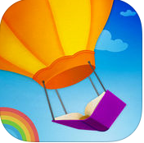 | Reading Rainbow Skybrary Family  By Reading Rainbow | Free – app with tons of books to read | https://itunes.apple.com/us/app/reading-rainbow-skybrary-family/id512350210?mt=8
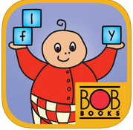 | Bob Books Reading Magic Sight Words  By Bob Books Publications LLC | $3.99 – books that use sight words | https://itunes.apple.com/us/app/bob-books-reading-magic-sight-words/id980639828?mt=8
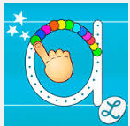 | Writing Wizard
 | Letter School
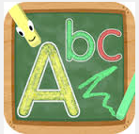 | Tracing ABC
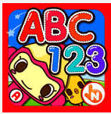 | ABC 123
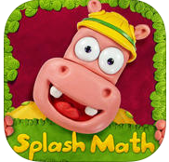 | Splash Math
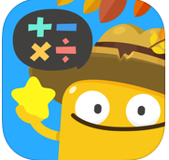 | Todo Math
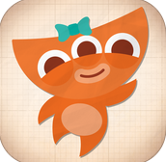 | Endless Numbers

