Math Apps
Math OPS | 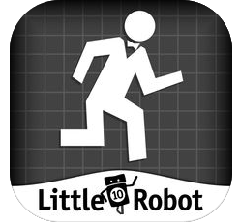 | https://itunes.apple.com/us/app/operation-math/id487387270?mt=8
10 Monkeys | 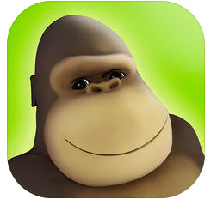 | https://itunes.apple.com/us/app/10monkeys-multiplication/id660188693?mt=8
Sushi Monster | 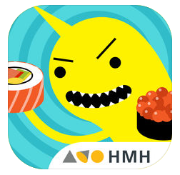 | https://itunes.apple.com/us/app/sushi-monster/id512651258?mt=8
Math Edge X | 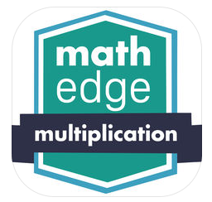 | https://itunes.apple.com/us/app/mathedge-multiplication-2017/id413842602?mt=8
Math Planet |  | https://itunes.apple.com/us/app/math-planet-fun-math-game-curriculum-for-kids/id828398560?mt=8

